**SOFTWARE TESTING ASSIGNMENT**

**MODULE – 1 (FUNDAMENTAL)**

1. **What is SDLC?**

* The Software Development Life Cycle (SDLC) is a structured process that enables the production of high-quality, low-cost software, in the shortest possible production time. The goal of the SDLC is to produce superior software that meets and exceeds all customer expectations and demands.
* SDLC is a structure imposed on the development of a software product

that defines the process for planning, implementation, testing,

documentation, deployment, and ongoing maintenance and support.

* There are a number of different development models.
* The Software Development Life Cycle (SDLC) refers to a methodology with clearly defined processes for creating high-quality software.

1. **What is software testing?**

* Software testing is the process of evaluating and verifying that a software product or application does what it is supposed to do. The benefits of testing include preventing bugs, reducing development costs and improving performance.
* It can also be stated as the process of validating and verifying software program or application or product.
* In other words, Testing is the process of evaluating a system or its

component(s) with the intent to find that whether it satisfies the specified requirements or not.

1. **What is Agile Methodology?**

* The Agile methodology is a way to manage a project by breaking it up into several phases. It involves constant collaboration with stakeholders and continuous improvement at every stage. Once the work begins, teams cycle through a process of planning, executing, and evaluating.
* Agile SDLC methodology is a combination of iterative and incremental process models with focus on process adaptability and customer satisfaction by rapid delivery of working software product.
* Agile model believes that every project needs to be handled differently and the existing methods used to be tailored to best suit the project requirements. In agile the tasks are divided to time boxes to deliver specific features for a release.

1. **What is SRS?**

* A software requirements specification (SRS) is a document that describes what the software will do and how it will be expected to perform. It also describes the functionality the product needs to fulfill all stakeholders (business, users) needs.
* SRS (software requirements specification document) is nothing but one kind of document in which there is complete description of the behaviour of the system to be developed.
* SRS includes a set of use cases that describe all of the interactions that the user will have with the software.

1. **What is OOP?**

* Object-oriented programming (OOP) is a computer programming model that organizes software design around data, or objects, rather than functions and logic.
* OOP focuses on the objects that developers want to manipulate rather than the logic required to manipulate them. This approach to programming is well-suited for programs that are large, complex and actively updated or maintained. This includes programs for manufacturing and design, as well as mobile applications; for example, OOP can be used for manufacturing system simulation software.

1. **Write Basic Concepts of OOPs.**

* Object
* Class
* Encapsulation
* Inheritance
* Polymorphism
* Abstraction

1. **What is Object?**

* In Object-Oriented programming (OOP), objects are the things you think about first in designing a program and they are also the units of code that are eventually derived from the process.
* In simple word, any entity which has its own state and behaviour that is called an object.

1. **What is class?**

* In Object-Oriented Programming, a class is a blueprint for creating objects (a particular data structure), providing initial value for state (member variables or attributes), and implementations of behaviour (member functions or methods). The user-defined objects are created using the class keywords.
* In simple words, Class is a collection of objects.
* A class represents an abstraction of the object and abstracts the

properties and behaviour of that object.

1. **What is Encapsulation?**

* Encapsulation is one of the fundamental concepts in OOP that bundles data and associated methods that operate on that data into a single block called class. It is also seen as a pathway for restricting direct access to some data and methods associated with a class (which leads to data hiding).
* Encapsulation is the practice of including in an object everything

it needs hidden from other objects. The internal state is usually not accessible by other objects.

**10) What is Inheritance?**

* When a class derives from another class. The child class will inherit all the public and protected properties and methods from the parent class. In addition, it can have its own properties and methods. An inherited class is defined by using the extends keyword.
* Inheritance is a mechanism in which one class acquires the property of another class. For example, a child inherits the traits of his/her parents. With inheritance, we can reuse the fields and methods of the existing class. Hence, inheritance facilitates Reusability and is an important concept of OOPs

**11) What is Polymorphism?**

* Polymorphism is a feature of object-oriented programming languages that allows a specific routine to use variables of different types at different times. Polymorphism in programming gives a program the ability to redefine methods for derived classes.
* In simple words, many ways to perform any task.

**12) Draw Usecase on Online Book Shopping.**

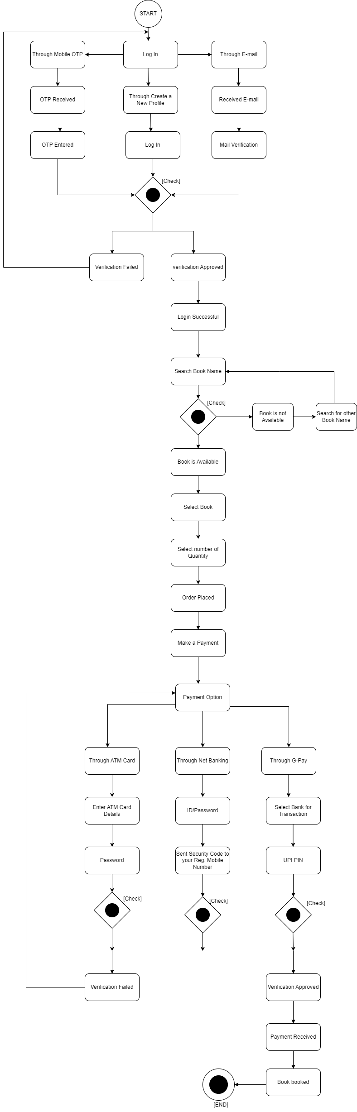

**13) Draw Usecase on Online Bill Payment system (paytm).**

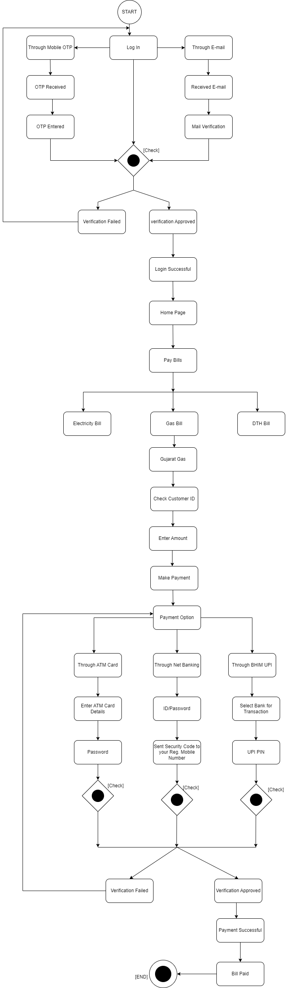

**14) Write SDLC phases with basic introduction.**

* **Requirement Gathering:** The first phase of SDLC is requirement gathering from customer. Here we gathered requirement of functional and non-functional requirements by customer.
* **Analysis:** The second phase of SDLC is analysis of gathered requirements from customer. And analyse how these requirements will be accomplished.
* **Design:** The third phase of SDLC is design phase, on the basis of analysis of gathered requirement. In this phase the software design documents are prepared. There are two kind of design document HLD & LLD .
* **Implementation:** The forth phase of SDLC is implementation In this phase developer start the develop build by writing the code.
* **Testing:** The fifth phase of SDLC is testing, testing for giving bug free and quality product to the customer. In testing phase tester will check the application by the help of comparing expected result and actual result.
* **Maintenance:** The sixth phase of SDLC is maintenance, the maintenance phase comes after deployment of software. The maintenance can done by 3 techniques.
* Corrective maintenance
* Adaptive maintenance
* Perfective maintenance

**15) Explain Phases of the waterfall model.**

* The waterfall model is classical lifecycle model. There is some phases as below.
* Requirement Collection
* Analysis
* Design
* Implementation
* Testing
* Maintenance
* **Requirement collection:** The aim of this phase is to understand the need of the customer. The team will collect the requirement from customer and also convince the customer if any requirement not suitable.
* **Analysis:** The aim of this phase is to understand the exact requirement of customer and document them properly. Both the customer and developer work together.
* **Design:** This phase aim to transform requirement gathered into a suitable form. It defines overall software architecture with high level and detail design.
* **Implementation:** During this phase design is implemented. If design document is ready than coding phase proceed smoothly.
* **Testing:** This phase is highly crucial as the quality of the end product determined by the testing phase. The better output will give the quality product to the customer and low maintenance after deployment.
* **Maintenance:** Maintenance is the task performed by every user once the software has been delivered to the customer.

**16) Write the phases of spiral model.**

* + Planning
  + Risk analysis
  + Engineering/Construct
  + Customer Evaluation

**17) Explain working methodology of agile model and also write Pros. & Cons.**

* Agile SDLC model is a combination of iterative and incremental process models with focus on process adaptability and customer satisfaction by rapid delivery of working software product.
* The agile methodology is a way to manage a project by breaking it up into several phases. It involves constant collaboration with stakeholders and continues improvement at every stage.
* **Pros :**
* It is a very realistic approach to software development.
* Promotes team work and cross training.
* Functionality can be developed rapidly and demonstrated.
* Resource requirement are minimum.
* Suitable for fix and changing requirements.
* Delivers early partial working solution.
* Good model for environments that change steadily.
* Minimal rules, documentation easily employed.
* **Cons :**
* Not suitable for complex dependencies.
* More risk for sustainability, maintainability and extensibility.
* Strict delivery management dictates the scope, functionality to be delivered and adjustments to meet the deadlines.
* Depends heavily on customer interaction, so if customer is not clear, team can be driven in the wrong direction.
* There is very high individual dependency, since there is minimum documentation generated.
* Transfer of technology to new team members may be quite challenging due to lack of documentation.

**18) Draw Usecase on Online shopping product using COD.**

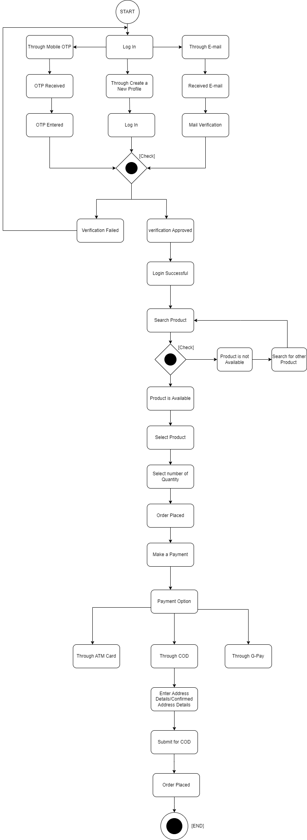

**19) Draw Usecase on Online shopping product using payment gateway.**

